**IFT 458/598: Middleware Prog & Database Security**

Anurag Shahare

Module 3 Assignment: Data Access

Dinesh Sthapit

October 1, 2022

Git: <https://github.com/AnuragShahare/M3A2/>

**Step 1**

**Step 2:**

**Step 3**

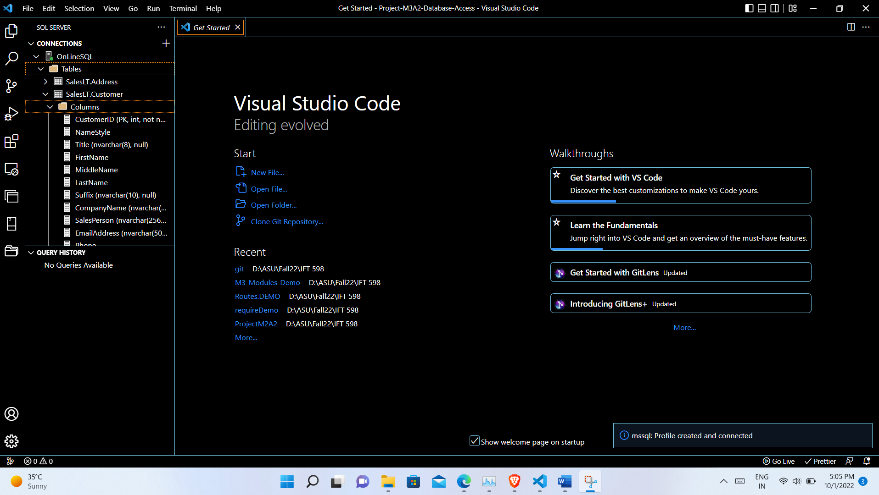

**Step 4**

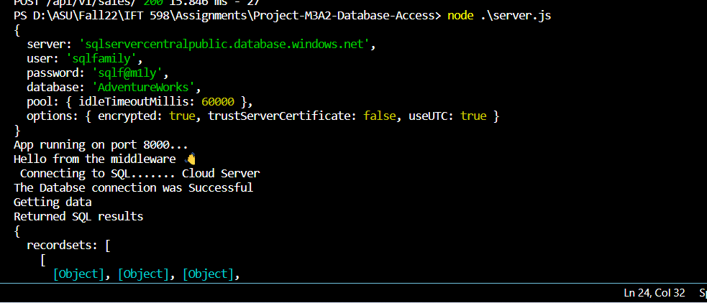

**Step 5:**

**Step 6:**

**Additional requirements:**

